Primerjava sedanjikov - Present Simple in Present Continuous

- Look at the picture on the right and complete the sentences (Simple Present or Present Progressive). Poglej si sliko na desni in dopolni povedi z ustreznim sedanjikom (Simple ali Continuous).
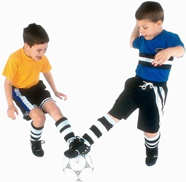
Joe and Dennis (be) _____________ best friends.
They often (meet) ___________ in the afternoon.
What (do / they) ________________ at the moment?
They (play) _______________ football.
They (love) ________________ football.
Joe (practise) ______________ with his father every weekend, but Dennis (not / play) ______________football very often.
- Fill in the blanks with the correct form of the present tense ! Povedi dopolni z ustrezno obliko sedanjika (Simple ali Continuous).
- The children ______________out in the garden now (PLAY).
- She usually ______________the newspaper in the morning . (READ)
- I ______________my homework now. (DO)
- Jack ______________ his dinner at the moment (EAT).
- ______________a pizza ? (YOU WANT)
- They ______________to watch TV in the evenings (LIKE)
- Be quite ! The baby ______________. (SLEEP).
- He______________ to his pen friend every month (WRITE).
- She ______________ football (NOT LIKE).
- The girls ______________now. All of them ______________a film (NOT TALK, WATCH).

