IN TOWN – REVISION
A
True (Prav) or False (Narobe)? Preberi trditve in označi ali so pravilne (T) ali napačne.

V zvezek zapiši vse povedi, seveda pravilno.

- You can send a letter in a police station.
- You can buy books in a library.
- You can see monkeys in a bank.
- You can buy sandwiches in a supermarket.
- You can see old things in a museum.
- You can take a dog for a walk in a swimming pool.
- You can borrow books in a bookshop.
- You can go to school when you are sick.
- You can buy bread in the bakery.
- You can dance in the church.
- When you want to watch a film, you go to the ZOO.
- When you are hungry, you can go to the bank.
- You can buy a fish tank in a clothes shop.

B Vstavi ustrezen predlog (IN, ON, UNDER, NEXT TO, BETWEEN, OPPOSITE, IN FRONT OF, BEHIND) glede na sličico. Povedi zapiši tudi v zvezek za vaje.

The ball is ____________ the desk and the bed.
SLOVARČEK:

a rug = preproga
a doll – punčka (igrača)
shelves = police
a lamp = namizna svetilka

a plant = rastlina
a pot = lonček (posoda)
a wall = stena
a paintbrush = čopič

The shoes are _______ the desk.
The plant is ___________ the pot.
The rug is __________ the bed.
The lamp is _________ the desk.
The book is _________ the pencil and the lamp.
The lamp is __________ the book.
The picture is _________ the wall.
The rug is ___________ the doll and the palette.
The paintbrush is ________________ the palette.
The palette is __________ the ball.
The teddy bear is _____________ the bed.
The books are ___________ the shelves.
The radio is _______ the shelf.

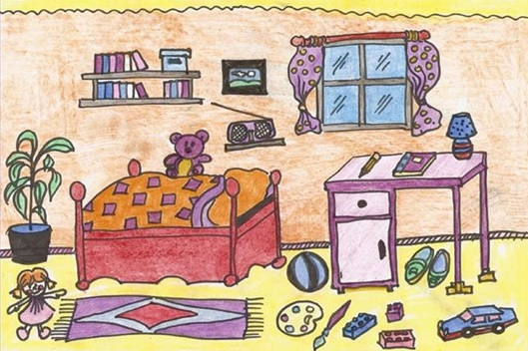
POMNI
IN = v
ON = na
UNDER = pod
NEXT To = poleg, zraven

BETWEEN = med
OPPOSITE = nasproti
IN FRONT OF = pred
BEHIND = za, zadaj

