**PREVERJANJE ZNANJA – CLASS 6**

*A Complete the sentences with the correct form of the verbs in brackets. Use the present simple tense. / Dopolni povedi s pravilno obliko glagolov v tabeli. Uporabi* ***present simple****.*

*ACTIVITY 1*

1 Mia and Leo ___________________ (have got) many posters.

2 They ________________________ (not like) my new car.

3 Sandra __________________ (have) dinner at 8 o’clock.

4 ________ Greg ______________ (write) songs? - Yes, he does.

5 Nick _______________________ (eat) dessert after lunch.

*ACTIVITY 2*

1) Sue ____________________ (play) three musical instruments.

2) I ____________________ (not wear) glasses.

3) Hanks ____________________ (study) history and geography.

4) _____________ you ________________ (like) vegetables? -Yes, I _____________.

5) My friends ____________________ (not eat) a lot of fruit and vegetables.

6) My colleague and I ___________________ (collect) stamps.

7) _____________ Joe _________________ (live) in Spain? - No, he _______________.

8) Janet __________________ (watch) films on her PC.

*B* ***PRESENT SIMPLE****: Make sentences. Use the affirmative, negative and interrogative form. /* ***PRESENT SIMPLE****: Tvori povedi v* ***trdilni*** *(+),* ***nikalni*** *(-) in* ***vprašalni obliki*** *(?).*

1. + We _________________ (watch) a lot of comedies.

- ______________________________________________________.

? ______________________________________________________?

1. + My boss __________________ (finish) his work at 9 p.m.

- _____________________________________________________.

? ______________________________________________________?

1. + You _________________ (swim) every Wednesday.

- _____________________________________________________.

? ______________________________________________________?

1. + They often ___________________ (smile).

- _____________________________________________________.

? ______________________________________________________?

*C Put the words in the right order and make sentences. / Uredi besede v pravilen vrstni red in napiši poved.*

1 always / he / dinner / eats / for / pasta/.

________________________________________________________________

2 goes/ bed / at / 7 o’clock / she / never / to/.

________________________________________________________________

3 to/ does / Simone / listen / why/ the / radio/ ?

________________________________________________________________

4 got / one / have / sister / I/ .

________________________________________________________________

5 never / she / happy / is/ .

___________________________________________________________

*D Complete the questions. / Dopolni vprašanja z ustreznimi vprašalnicami ali pa s pomožnim glagolom do/does oziroma s pravo obliko glagola “be”.*

1) ________________ subjects does Joe like at school? - Maths and history.

2) ________________do you get up in the morning? - At seven o’clock.

3) ________________ you believe in ghosts? - No, I don’t.

4) ________________ does Lily come from? - From Australia.

5) ________________ do you wants to go there? - Because it’s interesting.

6) ________________ you scared of storms? Yes, I am.

MCj04357310000[1]7)_________ Rok sing in a band? No, he ____________.

8) __________ they understand French? No, they ______________.

9) __________ Petra’s mother watch TV? Yes, she ______________.

*E Write the* ***clock time****s in words. / Z besedami zapiši, koliko je ura.*

1. 9:45 ____________________________________________
2. MC900411956[1]16:00 ____________________________________________
3. 3:25 _____________________________________________
4. 2:40 _____________________________________________

*F Label the pictures. / Kaj je na slikah?*

  

____________ ____________ ______________

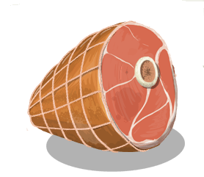   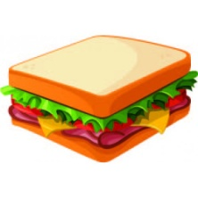

______________ ______________ _____________ ______________

 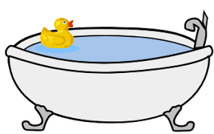

_____________ _______________

*G* **Circle the right answer.** *Obkroži pravilen odgovor.*

1 How are you? - I’m ___________. I have little energy today.

|  |  |  |
| --- | --- | --- |
| 1. fed | 1. good | 1. tired |

3 Everyone likes Mr. Brown’s son. He’s very ___________.

|  |  |  |
| --- | --- | --- |
| 1. friendly | 1. dangerous | 1. strong |

4 My dad always drinks coffee _____________ noon. He can’t start the day without it.

|  |  |  |
| --- | --- | --- |
| 1. in | 1. on | 1. at |

5 Molly usually _____________ behind her kitchen table.

|  |  |  |
| --- | --- | --- |
| 1. study | 1. studys | 1. studies |

6 We often have _____________seven o’clock in the morning.

|  |  |  |
| --- | --- | --- |
| 1. at | 1. on | 1. in |

*WRITING*

*H* **Describe your days. What do you do every day and at the weekend? When do you do it? Write about 60 words.** *Opiši svoj vsakdanjik in vikend. Kaj delaš vsak dan in ob kateri uri? Napiši približno 60 besed.*

*________________________________________________________________________________________________________________________________________________________________________________________________________________________________________________________________________________________________________________________________________________________________________________________________________________________________________________________________________________________________________________________________________________________________________________________________*