TEST – EXERCISES 3 - 6th grade

A Complete the sentences with the correct form of the verbs in brackets. Use the present simple tense. / Dopolni povedi s pravilno obliko glagolov v tabeli. Uporabi present simple.

1) Jane ____________________ (play) three musical instruments.
2) I ____________________ (not wear) glasses.
3) Tom ____________________ (study) history and geography.
4) _____________ you ________________ (like) bananas? -Yes, I _____________.
5) My brother ____________________ (not eat) a lot of fruit and vegetables.
6) My friend and I ___________________ (collect) stamps.
7) _____________ Joe _________________ (live) in Spain? - No, he _______________.
8) Janet __________________ (watch) films on TV.

B PRESENT SIMPLE: Make sentences. Use the affirmative, negative and interrogative form. / PRESENT SIMPLE: Tvori povedi v trdilni (+), nikalni (-) in vprašalni obliki (?).

- + They _________________ (read) a lot of horror stories.
- ______________________________________________________.
? ______________________________________________________?

- + My dad __________________ (finish) his work at 10 p.m.
- _____________________________________________________.
? ______________________________________________________?

- + I _________________ (swim) every Friday.
- _____________________________________________________.
? ______________________________________________________?

- + She often ___________________ (cry).
- _____________________________________________________.
? ______________________________________________________?

C Put the words in the right order and make sentences. / Uredi besede v pravilen vrstni red in napiši poved.

1) eats / Andrew / fish / never ______________________________________________________
2) visit / often / grandparents / I / my _________________________________________________
3) people / don’t / giraffes / attack / usually ____________________________________________
4) always / he / late / is __________________________________________________

D Complete the questions. / Dopolni vprašanja z ustreznimi vprašalnicami ali pa s pomožnim glagolom do/does oziroma s pravo obliko glagola “be”.

1) ________________ subjects does Joe like at school? - Maths and history.
2) ________________do you get up in the morning? - At seven o’clock.
3) ________________ you believe in ghosts? - No, I don’t.
4) ________________ does Sarah come from? - From Australia.
5) ________________ do you wants to go there? - Because it’s interesting.
6) ________________ you scared of thunder? Yes, I am.

E Write the clock times in words. / Z besedami zapiši, koliko je ura.

1) 6.30 ___________________________ 4) 3.50 __________________________
2) 2.15 ___________________________ 5) 11.00 __________________________
3) 8.05 ___________________________ 6) 7.35 ___________________________

F Label the pictures. / Kaj je na slikah?

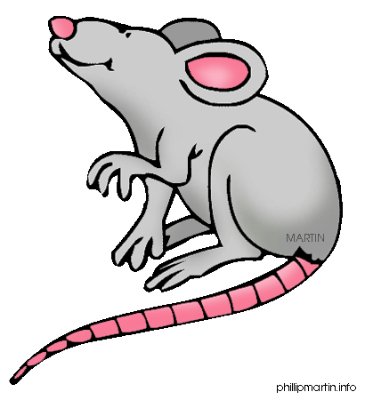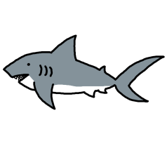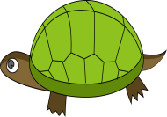

__________ ____________ ____________ ____________ ____________ ___________

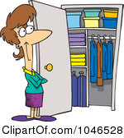

____________ ____________ ______________ ______________ ________________

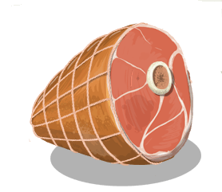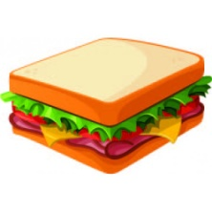

______________ ______________ _____________ ______________ ______________

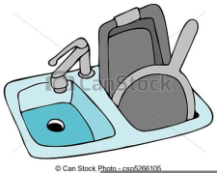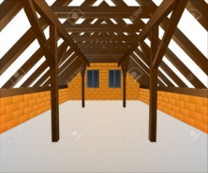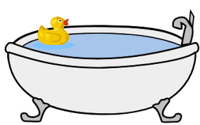

_____________ _______________ ______________

G Complete with the names of the places and rooms. / Dopolni povedi z izrazi za prostore v hiši ali ob njej
.
- You do the cooking in a k_________________.
- The television is usually in a l_________________ _________________.
- When you open the door and go into the house, you go into the h___________________.
- Big houses have sometimes got a swimming pool outside in the g__________________.

H Make true sentences about the town PIVKA. Use There’s / There isn’t /There are / There aren’t. / Opiši mesto Pivka. Tvori resnične stavke z uporabo There’s / There isn’t /There are / There aren’t.
Napiši vsaj 5 povedi. Glej primer: There’s a stadium. / There isn’t a swimming pool.

Shopping centre / bus station / tennis court / cinema / station / café /
school / post office / gym / river / park / church / museum /
aquarium / bowling alley / sports centre / castle / mountains / …

