MAVRIČNI KAMELEON (barvate lahko z navadnimi barvicami, voščenkami, flomastri)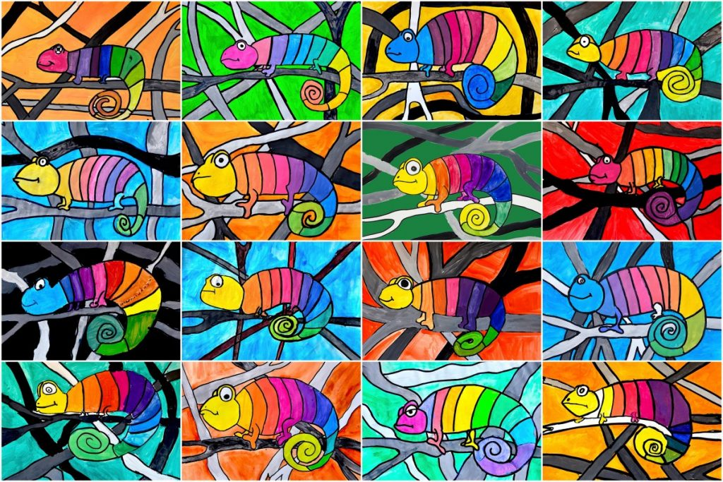

|  |  |
| --- | --- |
| Kako narišemo kameleona?[http://arteascuola.com/it/wp-content/uploads/2019/04/chameleon-451x1024.jpg](https://easydrawingguides.com/?s=chameleon) | [http://arteascuola.com/it/wp-content/uploads/2019/04/chameleon-451x1024.jpg](https://easydrawingguides.com/?s=chameleon) |

