Exercise A
Vstavi ustrezen predlog (IN, ON, UNDER, NEXT TO, BETWEEN, OPPOSITE, IN FRONT OF, BEHIND). Povedi zapiši tudi v zvezek.
The ball is ________ the desk and the bed.
The shoes are _______ the desk.
The plant is ___________ the pot.
The rug is __________ the bed.
The lamp is _________ the desk.
The book is _________ the pencil and the lamp.
The lamp is __________ the book.
The picture is _________ the wall.
The rug is ___________ the doll and the palette.
The paintbrush is ________________ the palette.
The palette is __________ the ball.
The teddy bear is _____________ the bed.
The books are ___________ the shelves.
The radio is _______ the shelf.

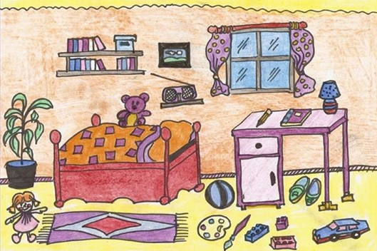
EXERCISE B
True (Prav) or False (Narobe)? Preberi spodnje povedi in preveri če so resnične. V zvezek zapiši vse povedi, napačne povedi ustrezno popravi.
You can send a letter in a police station.
You can buy books in a library.
You can see monkeys in a bank.
You can buy sandwiches in a supermarket.
You can see old things in a museum.
You can take a dog for a walk in a swimming pool.
You can borrow books in a bookshop.
You can go to school when you are sick.
You can buy bread in the bakery.
You can dance in the church.
When you want to watch a film, you go to the ZOO.
When you are hungry, you can go to the bank.
You can buy a fish tank in a clothes shop

EXERCISE C / *DODATNA VAJA: (reši po želji).
Ljubljana - the capital city of Slovenia. Napiši 5-7 povedi o prestolnici Slovenije v zvezek.
Write 5-7 sentences about Ljubljana into your exercise notebook.

